YUKKURI QUEST

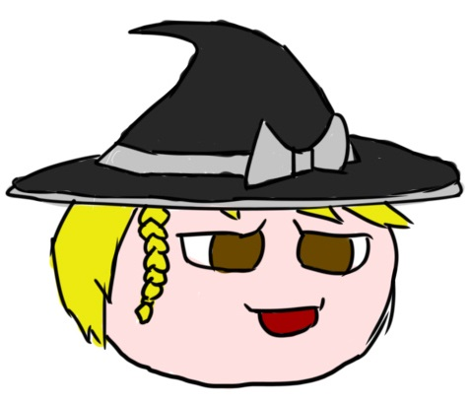

Add a note here**Game Story:**

Marisa went into adventure. Visit various place as a tiny creature such as Park, Pond, Roof and Forest. Collect Sweet and discover many thingAdd a note here before dinner.

**Game play:**

In Yukkuri Quest, the player is Marisa looking for sweet. The gameplay is platformer with 4 maps. Player may collect item such as sweet that can be accessed by solving puzzle. Player also must finish map to gain item and process to another map.

Add a note here**Elevator pitch:**

Add a note hereWatergirl and Lavaboy in Touhou Yukkuri Form

Add a note here**Player Character:**

Add a note here**Yukkuri Marisa:** Starting Game Marisa can only jump and move around. But after finishing map one (Park), she will be able to float on the water. Finishing map two (Pond) will make her be able to flight for short period of time. Finishing map three (Roof) would make her jump higher. Finishing map four (Forest) would make the game finish, and after that she will be able to travel freely.

Add a note here**Player controls (Keyboard):**

WASD/Arrow, normal Movement.

Holding Up, flight after receiving Mister Umbrella (Map One)

Double up, jump higher after receiving Mister boing boing (Map three)

Space, interact with other character

Add a note here**Game World:**

Add a note hereThe world of **Yukkuri Quest** is inspired by the charming farming world of Touhou Project, the simple watergirl and lavagirl puzzle platformer and cute image of hamtaro.

Add a note hereThe map isn’t large but full with puzzle that can be solved with cert

**Game Experience:**

The game is just simple puzzle platformer. Character can interact with other character to gain information about solving puzzle. Character can use item they gained to get new movement

Add a note here**How to win** – Get every sweet from every map

**Game Mechanics:**

Play in Yukkuri Quest in a 2D view of 2d Character, elements and terrain. The camera can’t be zoomed as its follow the main character. The minimap HUD helps player navigate the current map. And there are 5 maps in total. Various character scattered in the map to help the character and gained information about the world in general.

Yukkuri Quest player performs simple action, specific, bringing item to certain object, and collecting item. As game progress, player will receive item that will help them finish their quest.

Add a note here**Cutscenes:**

Add a note hereNarrative cutscenes will use in-game assets to simple dialogue along its character